**NEUTRAL BAY PUBLIC SCHOOL**

**P & C ASSOCIATION**

**Agenda of P&C Meeting 5/17**

**To be held on Wednesday 9 August 2017 at 7.30pm**

|  |  |
| --- | --- |
| **Agenda item** | **Document/speaker** |
| 1. **WELCOME AND APOLOGIES** | Sharmila Soorian |
| 1. **MINUTES FROM PREVIOUS MEETING** | As circulated |
| 1. **BUSINESS ARISING FROM MINUTES OF PREVIOUS MEETING** | Sharmila Soorian |
| 1. **CORRESPONDENCE** | Michelle Jackson |
| 1. **PRINCIPAL’S REPORT**  * **Naplan online** | David Shuster |
| 1. **TREASURER’S REPORT**   **Motion:** that the P&C pay the amount of $2,948 for P&C Federation membership and insurance (a slight increase from last year’s amount of  $2,883.00). | Jenny Spillane |
| 1. **SCHOOL COUNCIL REPORT** | David Jackson |
| 1. **SUB COMMITTEE REPORTS** 2. **Uniform Shop** 3. **Events and Functions** 4. **Band** 5. **Canteen** | Leslie Wait  Vanessa Baumer-Rowley  Band Committee  Alex Middleton |
| 1. **OTHER BUSINESS** |  |
| **2017 MEETING DATES**  *Wednesday 6 September*  *Wednesday 25 October*  *Wednesday 22 November*  *Wednesday 6 December (reserve)* |  |

**Attachments**

**7 Treasurer’s report**

Details of the insurance and P&C Federation costs which need to be paid are as follows:

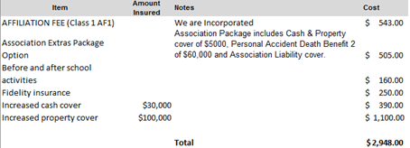

**8a Uniform shop report**

* Kate Jegat has left the employ of the P&C and Ginita Taylor (Mum of a Kindy student)

has taken over running the uniform shop (as a volunteer)

* Uniform Shop has been cleaned and tidied up
* Storeroom has been completely redone to ensure safety and for ease of understanding stock levels
* Second hand sale 1 August – very successful, over $800 made
* All second hand stock now moved out of storeroom in hall and accommodated in uniform shop
* Looking at new process for ordering uniforms for Kindy Info night; looking to use Flexi Schools only, currently working out the process and communications to go to the parents