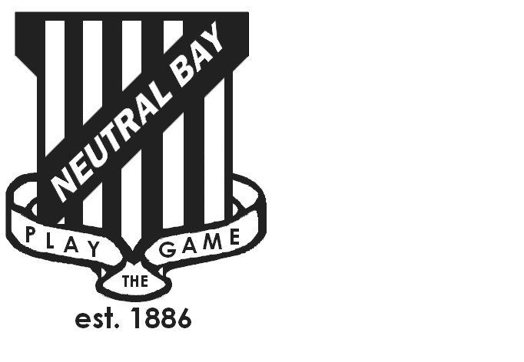
Neutral Bay Public School
Ben Boyd Road,
Neutral Bay, NSW 2089.
TEL: 9953 1798 FAX: 9904 1479
WEBSITE: www.neutralbay-p.schools.nsw.edu.au

SCHOOL COUNCIL MEETING
Wednesday 12th September 2018 8.00am
Senior Library

Present: Nadia Tobia, Genevieve Carnegie, Kim Thompson, Jess Keen, Rachel Partis, Julia Hudson, Lauren Irvine
Apologies: Jillian Skinner
Minutes: Rachel Partis
MEETING OPENED by Kim Thompson (President) at 8.05 am
PREVIOUS MINUTES
- Previous minutes approved by Jess Keen
- Kim Thompson acknowledged and thanked Nadia Tobia for her hard work and the care and commitment she has shown to students and staff over the past 12 weeks, in her role as Acting Principal at NBPS. Nadia will return to Mosman Primary School as Deputy Principal for the start of Term 4. In Term 4, NBPS will welcome new Principal, Judy Goodsell.
- Action from previous minutes;
  - Action: BASC grant update. Moved to next meeting in Term 4 once Project Reference Group has been set up by NSW DoE.
  - Action Code of Conduct & Grievance Policy: Review moved to next meeting in Term 4 after appointment of new Principal. RP to circulate revised copy of both documents with NBPS School Council wording prior to first meeting in Term 4.
  - Action: Feedback sent to Nadia Tobia on NBPS Bullying Info Sheet.
AGENDA ITEM 1: DECLARATIONS OF INTEREST
Nil.
AGENDA ITEM 2: PRINCIPAL’S UPDATE
Reviewed info from Council re Bullying Information sheet. Discussed option to include two sided Info Sheet – one page with info and resources dedicated to parents and the second with resources and information aimed at children. Suggestion to include soft copy version with hyperlinks for easy access to info and a brief summary of the resource. Action: RP to provide additional info on summary of resources.
Reviewed feedback from Council re possible survey to parents to review the effectiveness and purpose of the various methods of communication NBPS currently uses to communicate to the parent community ( Facebook, website, newsletter, app, pupil post, text ). Suggestion to leave this until start of Term 4 when new Principal Judy Goodsell starts. Action: ALL: Discuss next meeting.
Nadia provided an update on future focused and open learning. A number of staff members attended a workshop on open learning and how it can be used in the classroom and within schools. The workshop provided professional learnings and context on how open learning facilitates student learning and how with the right support and guidance it can give more control to children, on how and where, they learn.
Nadia advised that playground updates are planned in the corner of J Block to include possible additional seating and creative arts spaces for students. Genevieve Carnegie is working on this with the SRC.
Nadia advised that the Tell Them from Me Survey would be sent to all parents and carers via email and newsletter towards the end of Term 3 so that the information could be collated and reviewed in Term 4.
NBPS 2018 September Budget: September Schools Overview Report was reviewed. Judy to provide a more detailed overview in the next meeting.
AGENDA ITEM 3: NBPS FUTURE PLAN
NSW DoE notified Nadia that Kerrie Ross will be the Project Officer for the NSW DoE Project Reference Group. The PRG will consist of the Director of Schools, Principal, Department of Schools Infrastructure representatives including a project manager ( Kerrie Ross ) and architect and NBPS representatives.
NBPS Council is required to nominate a parent representative to sit on the Project Reference Group in addition to a member of the NBPS P&C.
Action: Council to nominate a representative for the PRG and share with Judy Goodsell at the next meeting.
AGENDA ITEM 4: APPOINTMENT OF NEW PARENT REPRESENTATIVE
At the time of meeting no official nominations for NBPS Council Representatives had been received. One verbal expression of interest had been received by an existing member. It was discussed and acknowledged that the process may be offputting for some prospective candidates and should be reviewed at the next meeting and discussed at the P&C Meeting on 12th September.
One option discussed, was that an expression of interest is forwarded to the Returning Officer outlining the reason for the nominees interest and providing some background on their relevant skills and capabilities. In the event there is more than one expression of interest, nominees will be required to provide the Returning Officer with a formal statement to allow P&C members the opportunity to review and vote for their preferred nominee.
Action: RP to discuss and review this at the P&C meeting on 12th September.

AGENDA ITEM 5: CODE OF CONDUCT
Review of Code of Conduct and Grievance Policy moved to first meeting in Term 4 when new Principal has been appointed.
Action: RP to adapt wording for NBPS School Council and circulate before the next meeting for review.
OTHER
- Discussion of the election process for newly elected parent representatives at the 12th September P&C highlighted that the process needed to be reviewed. Council suggestion listed in Agenda Item 4 was discussed and adopted by the P&C.
- Expression of interest by Jim Becker as Parent Representative was raised and Jim was elected as Parent Representative effective from 12th September un-opposed.
- Jim Becker will attend his first NBPS Council meeting on 7th November.

NEXT MEETING: 7th November 2018

