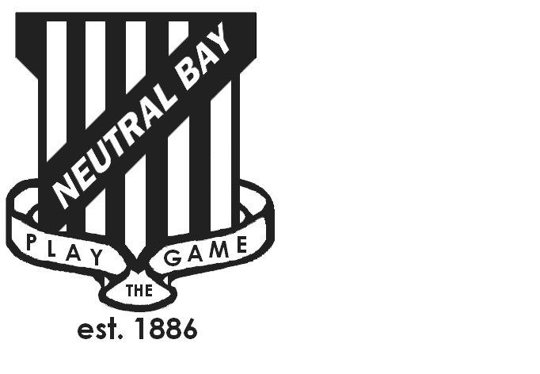
Neutral Bay Public School
Ben Boyd Road,
Neutral Bay, NSW 2089.
TEL: 9953 1798 FAX: 9904 1479
WEBSITE: www.neutralbay-p.schools.nsw.edu.au

SCHOOL COUNCIL MEETING
Wednesday 20th February 2019 8.00am
NBPS School Library

Present: Judy Goodsell, Victor Tan, Kim Thompson, Jillian Skinner, Jess Keen, Rachel Partis, Jim Becker, Brooke Saltmarsh, Jen Carew
Minutes: Rachel Partis
MEETING OPENED by Kim Thompson (President) at 8.03 am
PREVIOUS MINUTES
- Previous minutes approved by Jess Keen
- Kim Thompson welcomed Victor Tan, as Deputy Principal and Brooke Saltmarsh and Jen Carew as new Staff Representatives to the NBPS School Council.
- Update on actions from previous minutes;
  - Appointment of two new Staff Representatives ( see above).
  - Advertisement of vacancy of NBPS School Council Parent Representative to run in NBPS School Newsletter at least 14 days prior to the date of the NBPS P&C Meeting on 13th February 2019.

AGENDA ITEM 1: DECLARATIONS OF INTEREST
None received.
AGENDA ITEM 2: BUSINESS ARISING FROM MINUTES OF PREVIOUS MEETING
Update on NBPS Plan:
PRG No 4 – 18th March

Over the past months the project team have developed a good understanding of the site constraints and heritage. They are considering:

- the condition and lifespan of existing buildings we keep or replace
- access for students and deliveries
- improvements to playspace
- how we keep the school operational and safe during building
- The timeline depends on the preferred option and the number of stages to deliver that option.

AGENDA ITEM 3: PRINCIPAL’s REPORT
School Plan 2019 and Priorities:
School Vision Statement:

Following staff and community consultation, the vision statement is:

Neutral Bay PS promotes excellence in education, innovation in learning and opportunities for all students to achieve their personal best.

The Leadership Team has evaluated the impact of 2018 initiatives and set targets for each strategic direction. The 2019 Leadership Team will be using departmental data to revaluate the school plan this term. We have set up for 2019:

- Instructional Leaders – K-2 and 3-6 to drive the introduction of new syllabus documents, lead collective learning in the school (curriculum groups) and work with teachers in the classroom to model what works best in the classroom.
- Data informing practice: ACER testing and online NAPLAN
- Visible Learning- growth mindset and learning intentions
- PBL refining to improve consistency in managing negative behaviours- develop a flow chart
- Community engagement- Media Officer, Skoolbag App and Year 6 to 7 transition focus.
- Staffing- support programs initiated for students in Years 1, 2 and 3. Full-time teacher to run the Minilit and Maqqlit programs.

AGENDA ITEM 4: DATE AGREED FOR AGM 20th MARCH 2019
All positions on the NBPS School Council were declared vacant with nominations for;
President
Vice President
Secretary
Community Member (s)
To be determined at the AGM.
Action: Notice of the NBPS School Council AGM to be announced at the P&C on 20th February 2019 and to continue to be advertised in the NBPS School Newsletter.

AGENDA ITEM 5: OTHER.
Parent Representative Nominations: Two nominations were received with the vote to take place at the P&C Meeting of the same evening.

Recorded post the evening of 20th February 2019: Yasmin Tadich was voted as Parent Representative with her first meeting to be the AGM on 20th March 2019. We look forward to welcoming Yasmin to her first meeting at the AGM and the Ordinary meeting that follows this.

UPCOMING MEETINGS:
AGM Weds 20th March 2019
Ordinary Meeting Weds 20th March 2019 for members

