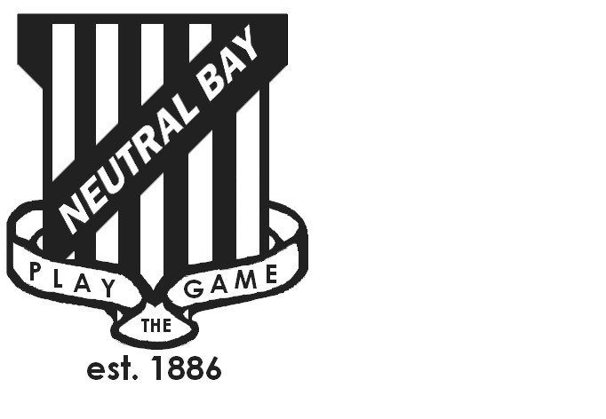
Neutral Bay Public School
Ben Boyd Road,
Neutral Bay, NSW 2089.
TEL: 9953 1798 FAX: 9904 1479
WEBSITE: www.neutralbay-p.schools.nsw.edu.au

SCHOOL COUNCIL MEETING
Wednesday 5th December 2018 8.00am
Second Floor Meeting Room

Present: Judy Goodsell, Genevieve Carnegie, Kim Thompson, Jillian Skinner, Jess Keen, Rachel Partis, Jim Becker, Julia Hudson, Lauren Irvine
Minutes: Rachel Partis
MEETING OPENED by Kim Thompson (President) at 8.04 am
PREVIOUS MINUTES
- Previous minutes approved by Jess Keen
- Kim Thompson thanked Lauren and Julia for their commitment and time to the NBPS School Council over the past three years.
- Update on actions from previous minutes;
  - Action: BASC grant update. Moved to first meeting in Term 1 once Project Reference Group has been set up by NSW DoE and meetings held.
  - Advertisement of new Parent Representative to be appointed in Term 1, nominations via newsletter as per changes detailed in minutes of meeting held on 7th November 2018
AGENDA ITEM 1: DECLARATIONS OF INTEREST
Jess Keen: Before and After School Care – non pecuniary interest.
AGENDA ITEM 2: BUSINESS ARISING FROM MINUTES OF PREVIOUS MEETING
Update on NBPS Plan:
PRG 3 to be held the following day on Thursday 6 December. The Community Values Meeting was held last week. Nine interested parents attended and 3 staff members. Groups worked collaboratively to consider school strengths, problems and solutions. Pleased to share that the strengths of the school were around student wellbeing, staff and teaching and learning. The negatives were facility related. Everyone was excited to consider the potential for the school should the facilities be enhanced.

AGENDA ITEM 3: PRINCIPAL’s REPORT
- Building and Grounds: train, synthetic grass, obstacle course and gumnut seating to be installed in January.
- Update on Teaching and Learning:
- Update on School Plan: Consultation with Leadership Team – Strategic Direction 1: Engaged, successful learners. This reflects our drive to create an engaging learning culture in the school and encompasses literacy, numeracy and visible learning.
- Gifted and Talented Committee: Provided professional learning to staff to ensure a common understanding of the identification process for Gifted and Talented students. Teachers have completed a nomination form and parents will complete a parent nomination form in Term 1 2019. Students put forward will be offered to sit an online General Ability Test. Students gaining a score above the benchmark will be flagged as Gifted and Talented.
- Teachers will be undertaking the GERRIC Mini-Certificate Course conducted by UNSW in Term 1 2019. This is a 16 hour course designed for teachers to gain an in-depth knowledge and understanding of effective strategies implemented to extend and enrich students.
- Staffing- currently filling 3 teacher vacancies.
- Thank you to Kim for being the Parent Representative on the merit selection panel. A targeted graduate is being recruited and the 3rd position will be filled by merit selection shortly.
- Student numbers steady at 960.
AGENDA ITEM 4: APPOINTMENT OF NEW PARENT & STAFF REPRESENTATIVES
Tenure of Jess Keen ( parent representative ), Julia Hudson and Lauren Irvine ( teacher representatives) are due to expire at the end of the year.
Nominations for Teacher Representatives are to be conducted by Judy Goodsell in Term 4.
Nominations for a Parent Representative are to be conducted in Term 1 2019.
AGENDA ITEM 5: OTHER
Before and after school care:
Declarations of interest – non-pecuniary, as noted above made by Jess Keen.
NBPS Council discussed the recent changes in staffing at NBCAG and the feedback that had been shared with some parent Council representatives by a small number of NBPS parents and carers. As a summary there was a request for greater understanding with regards to membership of the NBCAG committee and a commitment to support the work of the NBCAG committee.
Action: RP to follow up with John Bryne directly to understand protocol regarding membership of the NBCAG committee and clarity regarding how parents can be involved and better support the work of the NBCAG committee.
UPCOMING MEETINGS:
TERM ONE
Weds 20th February 2019
AGM Weds 20th March 2019
Ordinary Meeting Weds 20th March 2019

