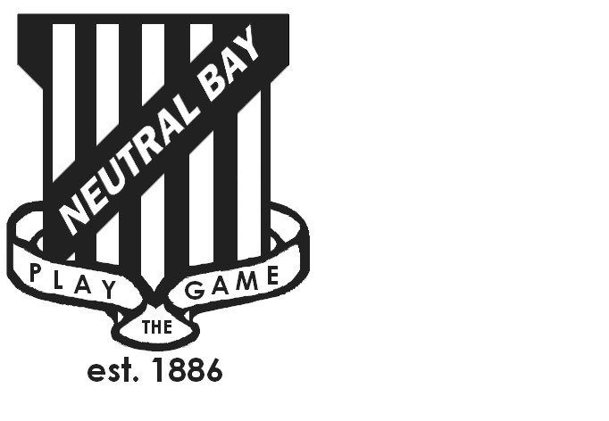
Neutral Bay Public School
Ben Boyd Road,
Neutral Bay, NSW 2089.
TEL: 9953 1798 FAX: 9904 1479
WEBSITE: www.neutralbay-p.schools.nsw.edu.au
Perc

SPECIAL GENERAL MEETING
Wednesday 28 March 2018 8.00am

Present: David Shuster, Kim Thompson, Jillian Skinner, Jessica Keen, David Jackson, Rachel Partis, Julia Hudson, Sharmila Soorian
Minutes: Rachel Partis
Apologies: Lauren Irvine
MEETING OPENED by Kim Thompson (President) at 8.05 am
NBPS SCHOOL COUNCIL CONSTITUTION
Sharmila Soorian requested clarity and re-wording of a number of clauses including;
II (c ) (iii). Requested clarity and an amendment to the wording of this clause to explain change in reference from two people to one. David Shuster advised that the roles of School Education Director and Regional Director no longer exist within the NSW Department of Education and had been replaced by the single role of Director of Schools. Council agreed to amend wording to clarify.
III (a) (ii). Requested change to capitalisation of Community Members. Council agreed to amend.
III (a) (iii). Requested clarity regarding wording of the maximum number of Executive Members. Council agreed to amend.
IV (c ). Requested change to capitalisation of Community Members. Council agreed to amend.
IV (m). Requested change to capitalisation of Community Members and clarity regarding change in reference from two people to one in line with the changes made in clause II (c ) (iii). Council agreed to amend.
V (a) (iv). Requested change to capitalisation of Executive Member. Council agreed to amend.
VI ( h). Requested clarity of wording and change to capitalisation of Executive Member. Council agreed to amend.
XII. ( a) Requested change to definition of Community Member in line with clause III ( a) (ii). Council agreed to amend.
XII. Requested additional definition of Executive Member be included in the list of definitions. Council agreed to amend.

David Jackson raised the question of whether a Code of Conduct could to be linked to the NBPS School Council Constitution.
It was resolved by Council that these were separate documents and a discussion regarding the development of a NBPS School Council Code of Conduct would be addressed in the subsequent meeting after the Special General Meeting.
Sharmila Soorian agreed to forward a copy of the P&C Code of Conduct to inform future discussions.
COUNCIL TENURE ALIGNMENT
It was resolved that tenure for David Jackson and Jess Keen’s term would be brought forward to the end of 2018 at the Annual General Meeting in line with the Constitution clause IV (b).
FUTURE MEETINGS
Special General Meeting to be held to recommend additional changes to constitution as discussed in meeting on 28 March 2018 as per Clause VIII (b) (i) of the current constitution.
Special General Meeting scheduled for 23 May 2018 Term 2 Week 4 at 8.00am.
SGM to be announced at least 14 days prior in the NBPS newsletter with details of time, location and date. A copy of proposed amendments will be lodged on the website at least 14 days prior to the Special General Meeting.
MEETING CLOSED at: 8.30 am

