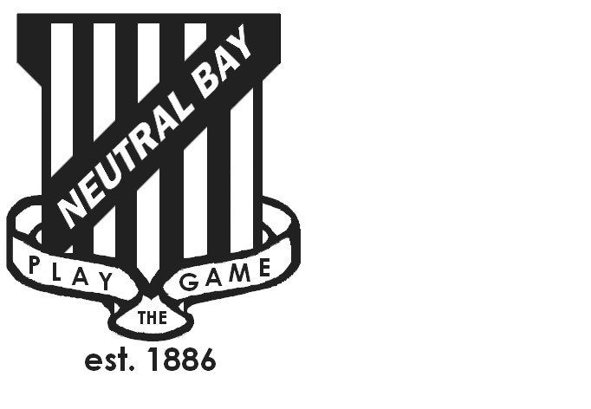
Neutral Bay Public School
Ben Boyd Road,
Neutral Bay, NSW 2089.
TEL: 9953 1798 FAX: 9904 1479
WEBSITE: www.neutralbay-p.schools.nsw.edu.au
Perc

School Council Meeting
Wednesday 21 February 2018 8.00am – 9.00am

Present: David Shuster, Kim Thompson, Jillian Skinner, Jessica Keen, David Jackson, Rachel Partis, Lauren Irvine, Julia Hudson
Minutes: Rachel Partis
Apologies: Nil
MEETING OPENED by Kim Thompson (President) at 8.05 am
PREVIOUS MINUTES
- Previous minutes approved by Jessica Keen
- Actions from previous minutes;
  - Pre-planning meeting to be held prior to Anthony Manning’s visit on 6th December 2017, Sharon Sands to be invited to the meeting – actioned no update
  - Meeting with Anthony Manning took place on 6th December 2017 as planned – see update below
  - Follow up letter sent to Anthony Manning and Joseph Lantz in December 2017 thanking them for their time – actioned still waiting on a written response as at 21 February 2018
  - Follow up email sent to Sharon Sands asking where we are at with the Future Plan – actioned in February 2018
  - Changes to NBPS School Council constitution loaded onto to NBPS website for review and reference – actioned in December 2017 and updated again in February 2018 together with updated contact details for NBPS School Council members
FUTURE PLAN
Positive meeting with Anthony Manning and Joseph Lantz on 6th December. Discussed school priorities of classroom and hall space. Discussed the capacity issues and the impacts on teaching and learning. Discussed proposed NBPS Future Plan. Anthony & Joseph viewed NBPS school including Kindyland, a number of classrooms, bathrooms, hall space and canteen.
Discussed that Sharon Sands key contact moving forward. Future correspondence should be directed to Minister, Rob Stokes and Sharon Sands.
Action: Rachel Partis to write a follow up letter to the Minister for Education, Rob Stokes, highlighting the school’s capacity issues, how it is impacting teaching and learning and re-stating the reasons why infrastructural changes are required. Copy in local North Shore member Felicity Wilson.
Action: David Shuster & Kim Thompson to follow up with Sharon Sands on recent correspondence. Response received on 28 February 2018.
PRINCIPAL’S REPORT
Staffing Update: Victor Tan to commence another Term in 2018 as Acting Principal at Pagewood Public School so will not be returning to NBPS in Term 1 2018. Bryony Herborn returns to NBPS in Term 1 as A/Principal. Office Manager role currently vacant.
In 2018 NBPS has 38 classes, 8 new staff and over 960 students. Key change to teaching staff in 2018 is the NBPS commitment to provide 2 x Instructional Leaders ( Kelly Lockhart and David Brown ) as a professional development and learning resource to NBPS teachers. Allows for team teaching, mentoring and peer support.
2018 Financial Plan presented including review of 2018 planned school budget report. Future NBPS SC meetings to include budget update.
NBPS staff are working on the development of a new three year school plan for NBPS (2018 – 2021). There is a commitment to Visible Learning and Collective Efficacy as discussed in previous meeting. Key focus is on child and parental feedback, learning intention and evaluation.
Parent Information & Community nights will continue into 2018 after positive feedback.
NBPS’ welfare program, PBL, is now entering phase 3 of its evolution. Key projects driving phase 3, like the Peer Support programme, will start in Term 2.
LOCAL CONSULTATION MEETING – BEFORE AND AFTER SCHOOL CARE
David Shuster and Rachel Partis attended a Local Consultation to discuss solutions to over subscription of before and after school care on 15th February 2018. Consultation was attended by other schools in the North Shore, Local Council Representatives, NSW Treasury, NSW Department of Education and relevant peak bodies. Forum to share information and best practice. Opportunities to follow up:
Action: Rachel Partis to follow up with NBCAG and NSW Treasury re $30,000 storage fund NBPS is eligible for.
Action: Rachel Partis & Jess Keen to follow up with nearby High Schools re the possibility of leasing space for potential additional offsite ASC locations ( Wenona School, Loretto Kiribilli and St Aloysius College).
NEW AFTER SCHOOL ACTIVITIES PROGRAMME
Rachel Partis updated Council on a new after school activities club, WOOSH CLUB that opened in February 2018. Extra curricular programmes are offered Monday – Friday to up to 30 children a day, a supervised walking bus picks children up from NBPS. Details of the club are available at NBCAG and the School office.
NBPS SCHOOL COUNCIL CONSTITUTION
Action: Special General Meeting to be held on 28th March 2018 in Term 1 2018 to approve the constitutional changes. 14 days notice required of Special General Meeting to be announced in newsletter.
Action: Announcement re Special General Meeting to be announced in newsletter at least 14 days prior.
Action: Code of conduct to be reviewed by NBPS School Council in second meeting of Term 1 2018.
FUTURE MEETINGS
Next meeting: Special General Meeting: Scheduled for 28th March 2018 Term 1 Week 9 at 8.00am.
MEETING CLOSED at: 9.12 am

