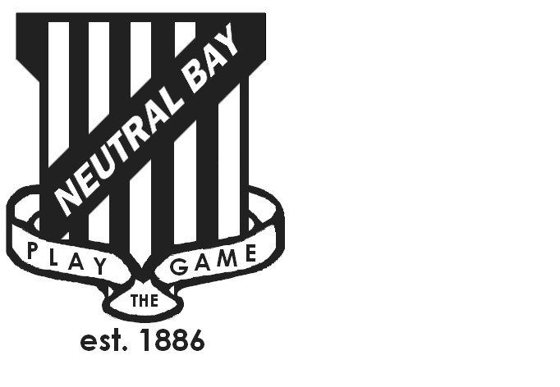
Neutral Bay Public School
Ben Boyd Road,
Neutral Bay, NSW 2089.
TEL: 9953 1798 FAX: 9904 1479
WEBSITE: www.neutralbay-p.schools.nsw.edu.au
Perc

SCHOOL COUNCIL MEETING
Wednesday 23 May 2018 8.00am

Present: David Shuster, Nadia Tobia, Genevieve Carnegie, Kim Thompson, Jillian Skinner, Jessica Keen, Rachel Partis, Julia Hudson, Lauren Irvine
Minutes: Rachel Partis
Apologies: David Jackson
MEETING OPENED by Kim Thompson (President) at 8.19 am
Welcome to Nadia Tobia ( Relieving Principal ) and Genevieve Carnegie ( Relieving Deputy Principal).
Congratulations to David Shuster on his appointment to the role of Principal, School Leadership (Regional North) effective from 28th May 2018.
Special mention of thanks to David Shuster for his contribution to NBPS over the past 3 years. In particular the following areas were noted; driving educational practice, instructional leadership and other leadership initiatives for NBPS staff, citizen and wellbeing initiatives with the introduction of PBL and the adoption of the Bay Way.
PREVIOUS MINUTES
- Previous minutes approved by Jessica Keen
- Action from previous minutes;
  - Action: Special General Meeting to be held on 23rd May 2018 to approve new constitution. Meeting held.
  - Action: Letter to Rob Stokes and Sharon Sands re Future Plan sent, dated 14th April, with amendments as discussed in the previous meeting.
  - Action: Letter to Sharon Sands to be followed up by Kim Thompson by phone before the next meeting. No response had been received by commencement of meeting on 23rd May.
  - Action: Rachel Partis to follow up with NSW Department of Education (DOE) re BASC grant. RP followed up and presented information to Council for discussion. See notes below to Agenda item 4.
  - Action: Rachel Partis and Jess Keen to follow up regarding potential of leasing space in local High Schools for potential additional offsite ASC locations. RP followed up with DOE. See notes below to Agenda item 4.
  - Action: Revisiting of options to install bollards inside NBPS school fencing on corner of Yeo and Ben Boyd road. Option to write to local North Shore member Felicity Wilson re discretionary funding. See notes below to Agenda item 6.
AGENDA ITEM 1: DECLARATIONS OF INTEREST
Jess Keen: Agenda items 4 ( BASC grant ) & 6 ( other ) both non-pecuniary.
AGENDA ITEM 2: PRINCIPAL’S UPDATE
David acknowledged the thanks and congratulations from Council regarding his new role.
Process for appointing new Principal was discussed. Merit selection panel is to be appointed over the next few weeks with one parent representative to be present on the panel. As discussed in the P&C meeting on 16th May, the requirement is for a male parent representative as the teacher parent representative appointed by NBPS staff is female. At the P&C meeting on 16th May, Kim Thompson was nominated as the first parent representative and Peter Carter the second parent representative should Kim be unable to attend.
Background to David’s new role was discussed. The Principal, School Leadership role is designed to support the professional learning, wellbeing and ongoing capabilities of school leaders in NSW public schools. More information can be found on the DOE website https://education.nsw.gov.au/teaching-and-learning/professional-learning/principal-school-leadership
2018 NBPS School Plan is to be presented by Nadia Tobia at the next NBPS School Council meeting. The new plan is currently available for review on the NBPS school website.
2018 NBPS Financial Plan was reviewed.
AGENDA ITEM 3: NBPS FUTURE PLAN
It was discussed that Council should follow up with Sharon Sands again for feedback to the letter sent to her, dated 14th April 2018. It was agreed not to follow up directly to the letter sent to NSW Minister Education, Rob Stokes until after the June budgets.
Further action re the Future Plan be reviewed after the NSW budget announcements on 13th June and in the next NBPS Council meeting.
Action: Kim to follow up with Sharon regarding recent correspondence dated 14th April.
AGENDA ITEM 4: BASC GRANT
Rachel updated Council on the options with regards to the BASC Grant from NSW Department of Education following conversations with the Project Officer for BASC fund (Edward OKulicz). Value of grant is $30,000. There is no current deadline to apply for the grant. Grant needs to be applied for by the school Principal. Grants can be issued to more than one provider if they exist at a school.
Rachel also discussed with the DOE Project Officer options regarding potential use of space at local High Schools and existing Council premises for potential additional ASC provision.
Council discussed options regarding what the $30,000 BASC grant could be used for. Suggestions included; a covered shade area between NBCAG office and school hall, other options that increased the space available for students, storage for equipment.
Action: Rachel to discuss with Libbie at NBCAG regarding next steps and to seek opinion of NBCAG committee.
Action: Rachel to follow up with High Schools directly re options for potential use of space for additional ASC provision.
AGENDA ITEM 5: CODE OF CONDUCT
Code of Conduct and Grievance Policy presented at the previous weeks P&C meeting was discussed. Council agreed to review at the next meeting.
Action: Rachel to adapt wording for NBPS School Council and circulate prior to the next meeting.
AGENDA ITEM 6: OTHER
An overview of road safety concerns in Cheal Laneway was sent to Council by a community member (hard copy powerpoint document titled Child Safety at Cheal Laneway). Jess Keen acknowledged the same document had been sent to North Sydney Council.
Action: Jess to provide an update at the next NBPS Council meeting re NS Council feedback.
Noted that NBPS parents had received communication that KU Forsyth Park will no longer be offering vacation care. North Sydney Council is currently tendering for a new provider.
Action: Jess to provide an update at the next NBPS Council meeting.
Noted decision made in offsite meetings with P&C President and NBPS School Council President not to send letter to local member Felicity Wilson re bollards until after NSW budget announcements.
MEETING CLOSED at: 9.14 am
NEXT MEETING: 20th June 2018

