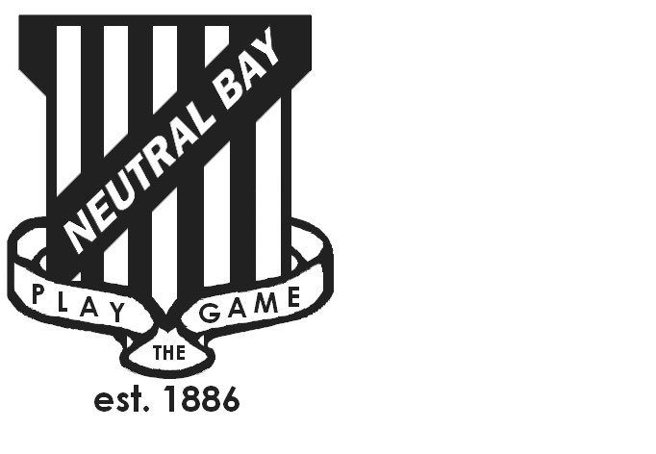
Neutral Bay Public School
Ben Boyd Road,
Neutral Bay, NSW 2089.
TEL: 9953 1798 FAX: 9904 1479
WEBSITE: www.neutralbay-p.schools.nsw.edu.au
Perc

SPECIAL GENERAL MEETING
Wednesday 23 May 2018 8.00am

Present: David Shuster, Nadia Tobia, Genevieve Carnegie, Kim Thompson, Jillian Skinner, Jessica Keen, Rachel Partis, Julia Hudson, Lauren Irvine, Sharmila Soorian
Minutes: Rachel Partis
Apologies: David Jackson
MEETING OPENED by Kim Thompson (President) at 8.03 am
NBPS SCHOOL COUNCIL CONSTITUTION
Amended NBPS School Council constitution was presented for approval.
Sharmila Soorian requested clarity regarding the date of the School Council AGM and why the wording was changed from “in the First Term after the P&C AGM” to “after the P&C AGM”. It was explained this was to allow for flexibility for the AGM to be held either later in Term 4 or in Term 1 following the P&C AGM.
Motion 1. That the revisions to the NBPS School Council Constitution presented in the meeting are accepted and replace the existing NBPS School Council Constitution on the NBPS School Council website.
Moved: Kim Thompson. Seconded Jess Keen. All agreed.
NEXT STEPS
Copy of new constitution to be signed and approved by Sharon Sands, Director of Schools, Department of Education and Kim Thompson, President of NBPS School Council and uploaded to the NBPS School Council website.
MEETING CLOSED at: 8.18 am

