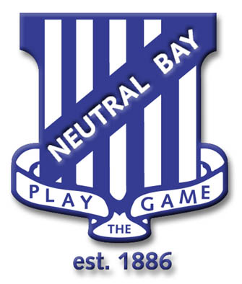
Neutral Bay Public School
175 Ben Boyd Road,
Neutral Bay, NSW 2089.
TEL: 9953 1798 FAX : 9904 1479
WEBSITE: www.neutralbay-p.schools.nsw.edu.au
EMAIL: neutralbay-p.school@det.nsw.edu.au

Notice of a student leaving the school
I would like to advise that my child _____________________ of class ______ will be leaving Neutral Bay Public School.
His/her last day of attendance will be ___________________________________________
Our child will be enrolling at ___________________________________________________
(name of school or country).

Checklist
- Have you returned all library books
- Paid school fees
Parent/Guardian Name ____________________________
Date ____/____/____

